UNIT: UkUlelE

ACT-Based Science: Sound Wave Visualization with a Tuning App
Objective:
Analyze sound waveforms using a tuning app.
ACT Score Target: 20-23
STUDENT DIRECTIONS:
Goal:
Use a tuning app to observe and analyze how frequency, pitch, and waveform relate to sound produced by a ukulele.
Step 1: Set Up Your Tools
Materials Needed:
- Ukulele
- Smartphone or tablet with a tuning app (such as Cleartune, Pano Tuner, or any app that shows waveform and frequency)
Make sure you're in a quiet environment, so background noise doesn't interfere with readings.
Step 2: Play and Record an Open String
- Choose one open string on your ukulele (e.g., the G string).
- Use the tuning app to pluck the string and record the following:
  - Pitch name (e.g., G4)
  - Frequency in Hz (e.g., 392 Hz)
  - Waveform shape on the display (draw or describe)

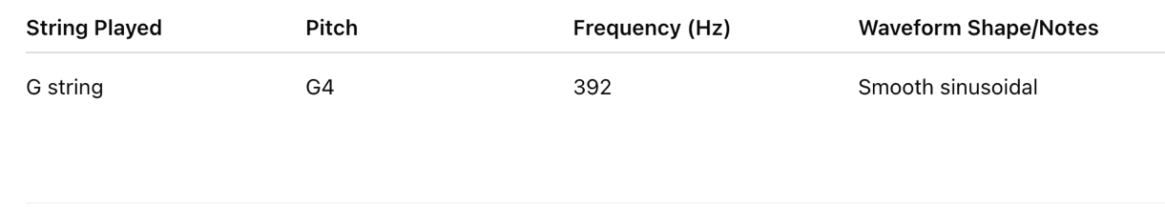
Fill in your notebook like this:

Step 3: Compare Different Notes
- Play a different open string (e.g., A, E, or C) or use the tuning pegs to tune one string higher or lower.
- Repeat the observation steps for the new note.
- Compare the waveforms:
  - Does the shape change?
  - Does the frequency increase or decrease?
  - How does the spacing of the waves (wavelength) differ?
Step 4: Analyze and Discuss
Write a brief summary (3–5 sentences) answering these questions:
- What happens to the waveform as the pitch goes higher?
- How do frequency and wavelength relate?
- Why is waveform analysis important for understanding sound?
Use scientific terms like frequency, wavelength, amplitude, and pitch in your explanation.
ACT-Style Question:
- What happens to the wavelength when a ukulele string is tuned to a higher frequency?
- Increases
- Decreases
- Stays the same
- Depends on the material

